
QUALITY ALERT

Customer: Vision Building Date: Nov 17, 2025
Die: 1020 Colour: Any
Type of Complaint: Customer REJECTED

Q.A # 25-065 NCR: 487 RMA#: N/A

Description: Customer REJECTED due to crooked internal wall, shifted toward right side, make it not fit in the punch.
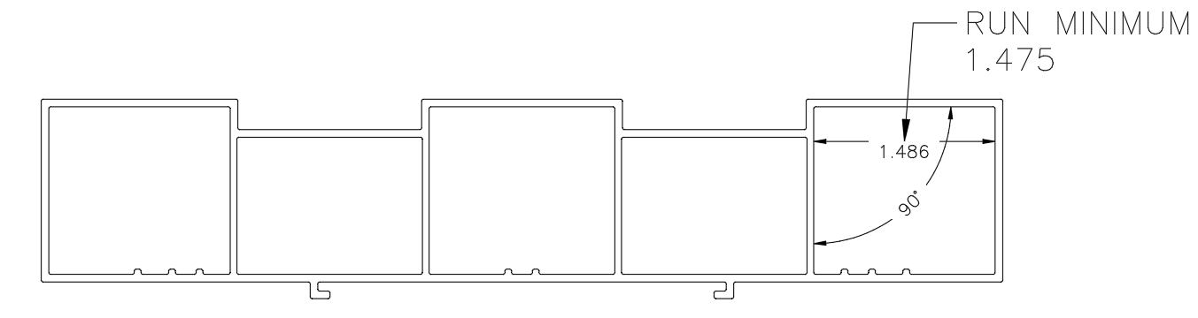

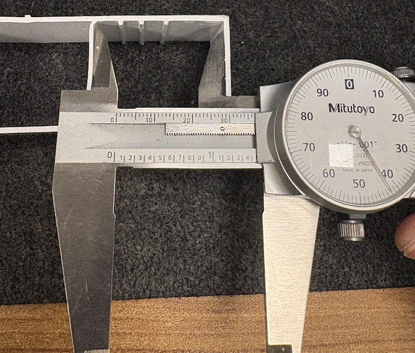
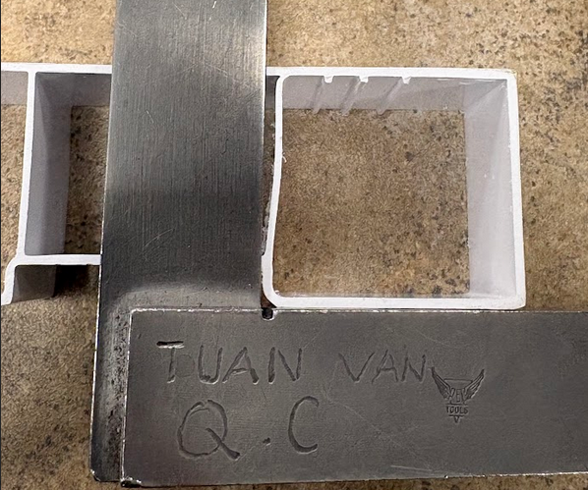
SHIFTED WALL

OFF DIMENSION

TRY TO KEEP INTERNAL WALLS AS STRAIGHT AS POSSIBLE, MAINTAIN DIMENSION WITHIN SPECIFIED TOLERANCE TO PREVENT FIT & FUNCTION ISSUES

BY SIGNING BELOW, YOU ACKNOWLEDGE THE PROBLEM ABOVE AND AGREE TO MONITOR THIS ISSUE IN FUTURE PRODUCTION RUNS.
DAY SHIFT |  | AFTERNOON SHIFT |  | NIGHT SHIFT
NAME | SIGNATURE | NAME | SIGNATURE | NAME | SIGNATURE

